Production Journal

Over the past four weeks, we were set to make a new website using a content management system. This task would be done in groups, comprised of two or three people, and adopt the SCRUM methodology. I was in a group with Jordyn Kerrison and Marissa Gaspari, and we used the Mid-Century Canberra source content to build our website. This was my first time every using WordPress, and I found it to be quite an interesting experience, especially partnering the collaborative process with an online tool such as GitHub. As with most projects, it has had its moments where you worry about whether it is working, but overall it has been a good project to work on.

The website, simply titled ‘Mid-Century Canberra’, features posts about many interesting buildings and architects during the 20th Century. We have separated the website into eight pages: homepage, posts (Canberra’s Growth), news, houses, architects, locations, about, and contact. Each page contains a series of posts relating to that topic, which can be briefly shown on the pages, and then expanded for people who wish to continue reading. The design of the website is quite simple, based on the Twenty Seventeen theme developed by the WordPress team. I downloaded this theme locally through FileZilla and then uploaded to GitHub for all members to make changes and additions to. After this, I then set up WordPress using a plugin called WP Pusher to pull the theme from GitHub and update whenever we pushed any updates we made locally to the GitHub origin. This made development of the website extremely easy and allowed us to keep track of any contributions done to the theme.

The concept of the SCRUM methodology, although understood, was something which we all did not refer to fully. We set up a Trello board and made a single sprint, as shown in Figure 1, with the thought that we would continue to add sprints after this. However, this did not happen, so our Trello board only consists of the pages which we were all meant to take care of. I was assigned to take care of the Architects and Houses pages and posts, Jordyn to take care of the Canberra Growth and News page, and Marissa the Locations, and originally the About/Contact page, which turned into separate pages. In making all these pages, many posts were needed to contain all the source content, which was then added to our database, as shown in Figure 2. We used a variety of plugins, such as maps for the locations page, WP Forms for the contact page, a carousel slider plugin for the images of the different houses, and as previously mentioned, a plugin to pull any updates to the theme from GitHub.

Throughout the process of developing this website, Jordyn and Marissa mainly focused on their pages throughout the four-week period and the styling, whereas I focused on my pages as well as hosting the web service, managing the back-end domain hosting and help with any technical issues that arose. Through doing this, however, it was difficult as I was hosting the website through a service called Site Ground. Whilst this was great, it was not as easy when it came to change the domain used to a custom domain I had purchased through GoDaddy. After some consultation with Ben, we managed to get the new domain to work and allowed us to continue developing our website. However, if this had not worked, we could have lost most of our work and needed to start from scratch. A backup of our website and database was saved using phpMyAdmin and FileZilla locally to my computer if something did go wrong, though luckily it was not required.

Overall, I believe this project to have been a success. The team worked quite well, although separately for most of the time, apart from time spent during tutorials. The website runs smoothly with no problems and has a pleasing aesthetic design which modern clients are looking to adopt. More time could have been put in by all of us, though due to other pressing assessment throughout our degrees we were unable to allocate this time. The most difficult part of this assessment was adopting the SCRUM methodology, as we did not use our original plan of the Trello board to its full extent. Although not fully used, it has been a useful tool the learn considering it is used as an industry standard. It has been a great experience learning these new tools such as WordPress, and I am excited to see where I use it next.

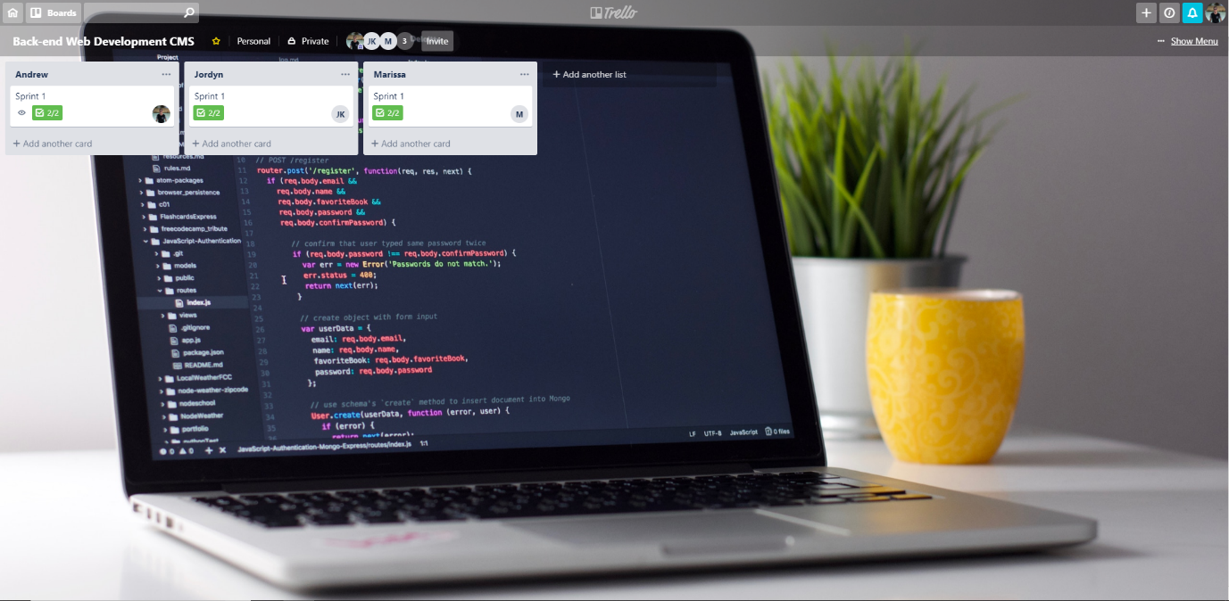

Figure 1 – Trello Board

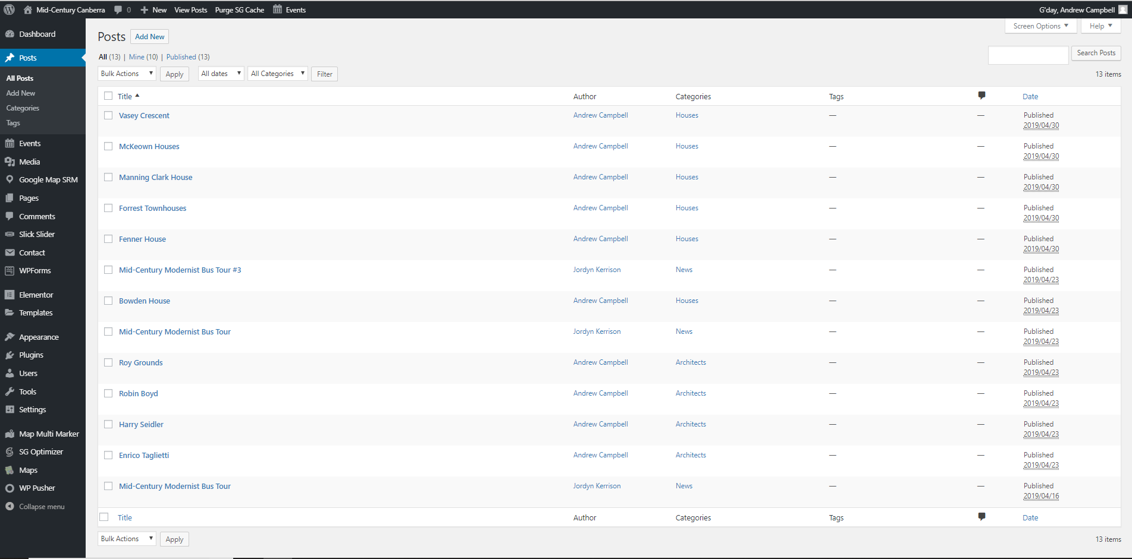

Figure 2 – WordPress Posts